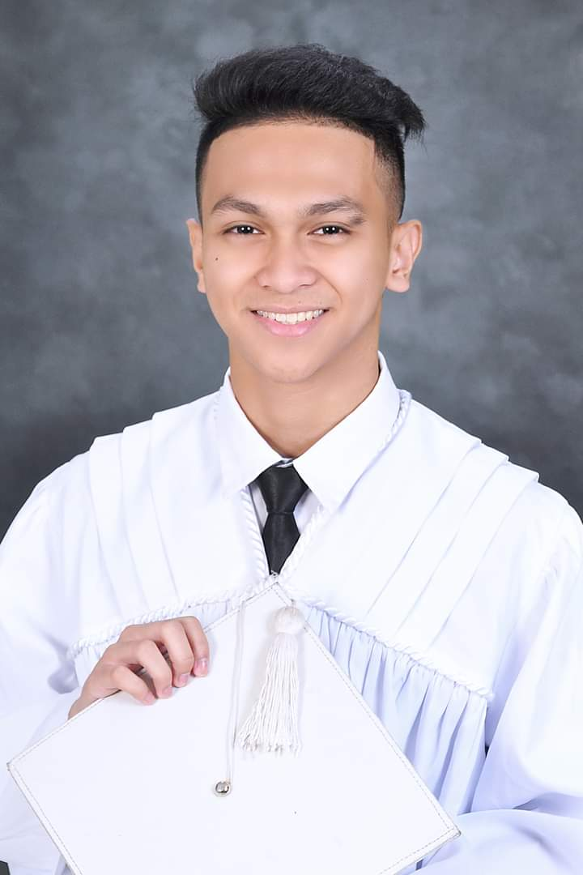**OLOROSO, JADE D.**

147 Sitio Mendez Barangay Baesa

Quezon City

0905 702 8879

jade.delima.oloroso@gmail.com

_____________

**PERSONAL INFORMATION**

**Date of Birth:** November 20, 2000

**Place of Birth:** Quezon City

**Citizenship:** Filipino

**Gender:** Male

**Civil Status:** Single

**Interest:** Playing guitar and watching movies/series, Playing Games

______________________________________________________________________

**EDUCATIONAL BACKGROUND**

**Primary:** Toro Hills Elementary School (2007-2013) at Road 18, Bahay Toro, Quezon City

**Secondary:** Pugad Lawin High School (2013-2017) at Seminary Road, Bahay Toro, Project 8, Quezon City

**Tertiary:** STI College Novaliches (2017-2019) at Diamond Avenue corner Quirino Highway, San Bartolome, Novaliches, Quezon City, 1116 Metro Manila

* Technical Vocational Track – Information and Communication Technology

Bachelor: Quezon City University (2019-present) at San Bartolome, Novaliches, Quezon City

* 3rd Year -Bachelor of Science in Information Technology

______________________________________________________________________

**PERSONAL QUALIFICATION**

* Broad knowledge in Web Design/UI Design
* Broad knowledge in Programming Language (Java, PHP, C#)
* Creative
* Management Skills
* Can work under pressure.
* Adaptability
* Teamwork Skills